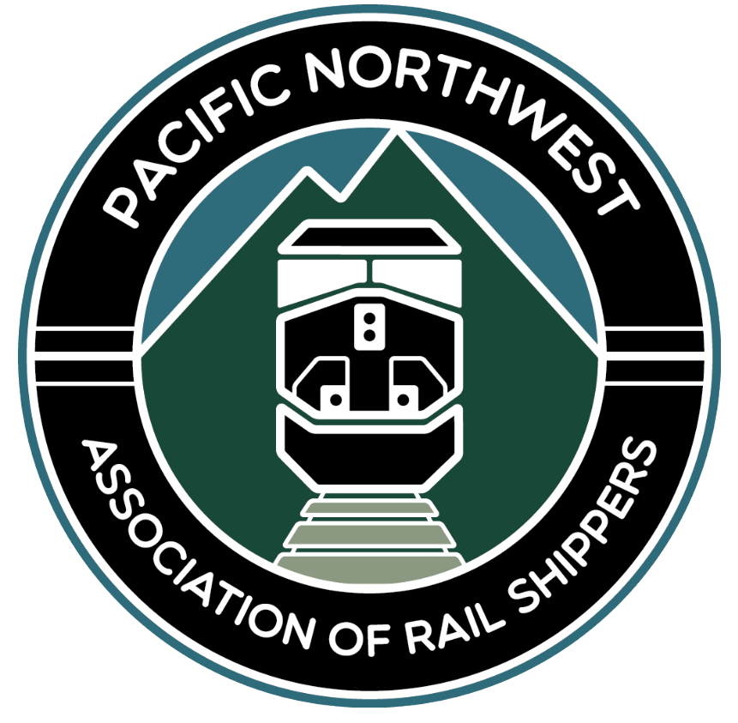
Pacific Northwest Association of Rail Shippers
2021 Annual Sponsorship

Gold Sponsorship - $8,500

Our Gold Sponsorship Package includes the following:
- Shown as a sponsor of Day 1 & 2 meeting event.
- Company promotion as Gold Sponsor on all items listed below.
- Company name, logo and website displayed during the virtual meeting and at www.pnrailshippers.com.
- Complimentary Registration – For up to three company representatives annually.
- 3-minute virtual advertisement during one of the conference available times and
- A 1-page advertisement displayed during the virtual meeting.

Silver Sponsorship - $5,000

Our Silver Sponsorship Package includes the following:
- Company promotion as Gold Sponsor on all items listed below.
- Company promotion as Gold Sponsor on all items listed below.
- Company name, logo and website displayed during the virtual meeting and at www.pnrailshippers.com.
- Complimentary Registration – For two company representatives annually.
- 3-minute virtual advertisement during one of the conference available times or a
- A 1-page advertisement displayed during the virtual meeting.

Bronze Sponsorship - $2,500

Our Bronze Sponsorship Package includes the following:
- Company promotion as Gold Sponsor on all items listed below.
- Company promotion as Gold Sponsor on all items listed below.
- Company name, logo and website displayed during the virtual meeting and at www.pnrailshippers.com.
- Complimentary Registration – For one company representative annually.
- A 1-page advertisement displayed during the virtual meeting.

Advertising Sponsorship - $1,000

- Company name, logo and website displayed during the virtual meeting and at www.pnrailshippers.com.

Virtual 1-Minute Advertisement/Sponsorship - $500

- 1-minute virtual advertisement during one of the conference available time slots (limited number of slots).

*The levels shown are not the only accepted amounts. We will consider other reasonable options that fit your companies’ budget.

