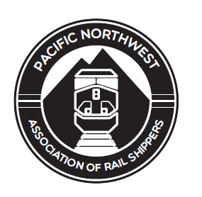
Pacific Northwest Association of Rail Shippers
2020 Annual Sponsorship

Gold Sponsorship - $8,500

Our Gold Sponsorship Package includes the following:
- Shown as a sponsor of Day 1 & 2 meeting event.
- Company promotion as Gold Sponsor on all items listed below.
  - Digital Signage – Your logo will be included in the digital signage that plays on a continuous loop in the meeting room pre-meeting, during breaks and transitions.
  - Online visibility with company profile – Acknowledgement of your company’s sponsorship, with your logo, company profile and a link to your website, will be prominently displayed on the official meeting website.
  - Sponsor Display Table – All sponsors are invited to display company promotional literature on the sponsor display table.
  - A 1-page advertisement in the printed conference book.
- Complimentary Registration – For up to three company representatives annually.

Silver Sponsorship - $5,000

Our Silver Sponsorship Package includes the following:
- Company promotion as Silver Sponsor on all items listed below.
  - Digital Signage – Your logo will be included in the digital signage that plays on a continuous loop in the meeting room pre-meeting, during breaks and transitions.
  - Online visibility with company profile– Acknowledgement of your company’s sponsorship, with your logo, company profile and a link to your website, will be prominently displayed on the official meeting website.
  - Sponsor Display Table – All sponsors are invited to display company promotional literature on the Sponsor display table.
  - A 1-page advertisement in the printed conference book.
- Complimentary Registration – For two company representative annually.

Bronze Sponsorship - $2,500

Our Bronze Sponsorship Package includes the following:
- Company promotion as Bronze Sponsor on all items listed below.
  - Digital Signage – Your logo will be included in the digital signage that plays on a continuous loop in the meeting room pre-meeting, during breaks and transitions.
  - Online visibility with company profile– Acknowledgement of your company’s sponsorship, with your logo, company profile and a link to your website, will be prominently displayed on the official meeting website.
  - Sponsor Display Table – All sponsors are invited to display company promotional literature on the Sponsor display table.
  - A 1/2-page advertisement in the printed conference book.
- Complimentary Registration – For one company representative annually.

Advertising Sponsorship - $1,000

- Company name, logo and website printed in conference book.

*The levels shown are not the only accepted amounts. We will consider other reasonable options that fit your companies’ budget.

